1.Install MySQL Workbench on your computer, connect to the local MySQL server, and take a screenshot of the default databases shown in the Schemas panel.
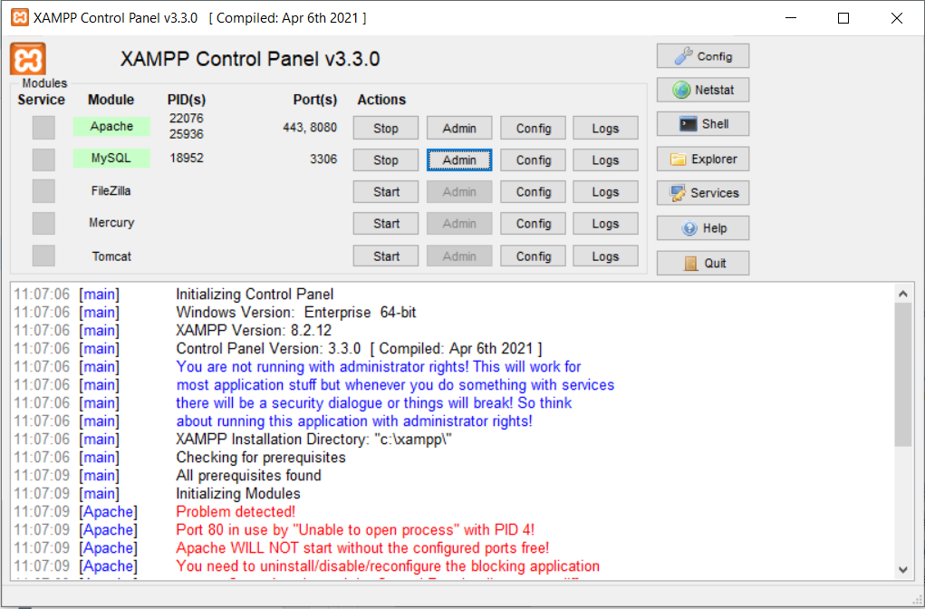
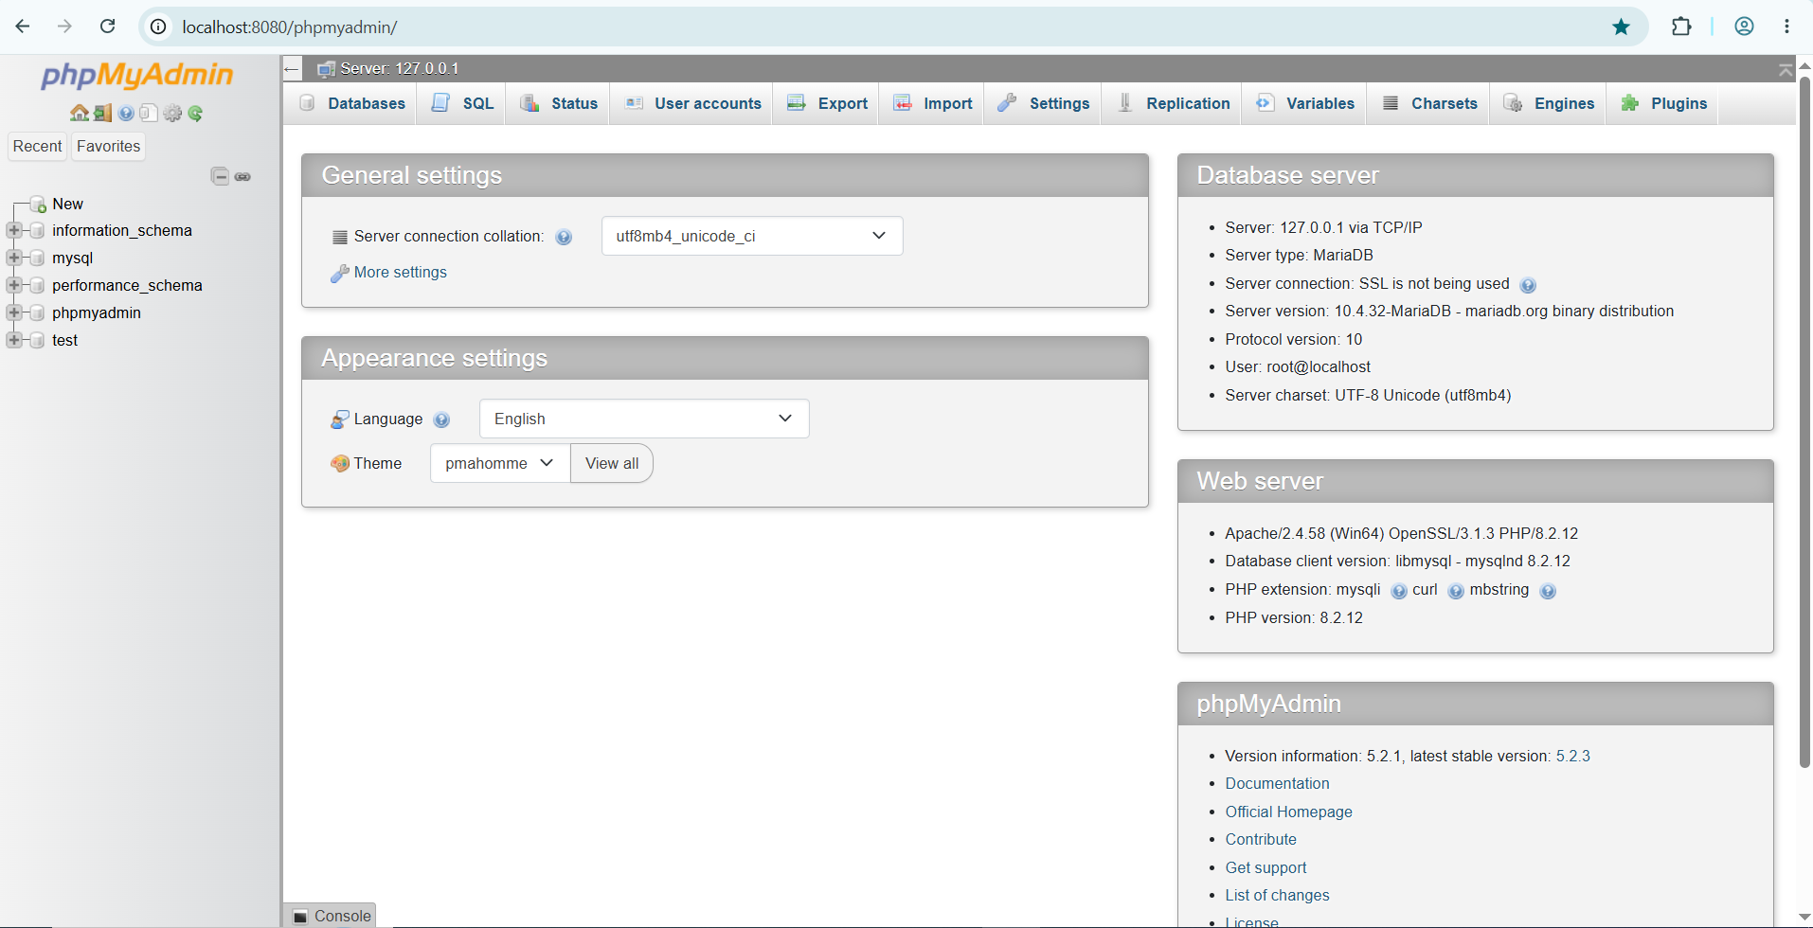

2.Create a new database called InstaClone in MySQL Workbench, then create a table named Users with columns: user_id (INT, primary key), username (VARCHAR), email (VARCHAR), and followers_count (INT).
-- Create the database
CREATE DATABASE InstaClone;

-- Select it for use
USE InstaClone;

-- Create the Users table
CREATE TABLE Users (
user_id INT PRIMARY KEY,
username VARCHAR(50),
email VARCHAR(100),
followers_count INT
);

3.Insert 3 sample users into the Users table you created, using realistic Instagram-style usernames and follower counts.
USE InstaClone;

INSERT INTO Users (user_id, username, email, followers_count)
VALUES
(1, 'travel_with_maya', 'maya.sharma@example.com', 12850),
(2, 'fit.arjun', 'arjun.patel@example.com', 4720),
(3, 'the.daily.brew', 'hello@dailybrew.example.com', 38600);

4.Create another table in the InstaClone database called Posts with columns: post_id (INT, primary key), user_id (INT), caption (VARCHAR), and post_date (DATE). Add a foreign key from Posts.user_id to Users.user_id to establish a relationship.
USE InstaClone;

CREATE TABLE Posts (
post_id INT PRIMARY KEY,
user_id INT,
caption VARCHAR(255),
post_date DATE,
FOREIGN KEY (user_id) REFERENCES Users(user_id)
);

5.Write a short comparison (3-4 lines each) of MySQL, PostgreSQL, Oracle, and SQLite, focusing on where each one is commonly used (for example: web apps, mobile apps, enterprise systems, etc.).
MySQL
MySQL is one of the most widely used databases for web applications, especially in the LAMP stack (Linux, Apache, MySQL, PHP). It powers platforms like WordPress, Facebook's early infrastructure, and countless small-to-mid-sized sites. It's known for being fast, easy to set up, and well suited to read-heavy workloads. It's open source, with a commercial edition from Oracle.
PostgreSQL
PostgreSQL is popular for complex web and analytics applications that need advanced features such as JSON support, custom data types, and strong standards compliance. It's a common choice for startups, fintech, geospatial work (via PostGIS), and data-heavy products. It's fully open source and valued for reliability and extensibility. Many teams pick it when they expect their queries and data models to get more sophisticated over time.
Oracle
Oracle Database is a staple of large enterprise systems such as banking, telecom, government, ERP, and airline reservations. It's built for very high transaction volumes, strict security, and mission-critical uptime, with features like advanced clustering and partitioning. It's a commercial product with expensive licensing, so it's usually chosen by large organizations that need vendor support and proven scale.
SQLite
SQLite is a lightweight, serverless database stored in a single file, which makes it ideal for mobile apps (Android and iOS), desktop software, browsers, IoT devices, and prototypes. There's no separate server to install or manage, since the database runs inside the application itself. It's not designed for many simultaneous writers, so it's rarely used as the main database for large multi-user web systems.
Quick summary
Database | Best known for
MySQL | Web apps, content sites, general-purpose use
PostgreSQL | Complex apps, analytics, geospatial, advanced features
Oracle | Large enterprise and mission-critical systems
SQLite | Mobile, embedded, and local single-user apps

